**GOOGLE PLAY STORE APP ANALYSIS**

Project submitted to the

SRM University – AP, Andhra Pradesh

for the partial fulfilment of the requirements to award the degree of

**Bachelor of Technology**

In

**Computer Science and Engineering**

**School of Engineering and Sciences**

Submitted by

Shreyashi Shankar Sinha - AP21110010273

S. Tejaswini - AP21110010299

Mayank Shukla - AP21110010157

Koduri C S N V Satyanarayana - AP21110011199

Under the Guidance of

**Dr. Banee Bandana Das**

**SRM University–AP**

**Neerukonda, Mangalagiri, Guntur**

**Andhra Pradesh – 522 240**

**Nov, 2023**

# Table of Contents

1. Abstract
2. Introduction
3. Methodology
4. Conclusion
5. References

# Abstract

This project uses Google Play Store data to understand user preferences and predict app trends. It aims to identify key factors influencing app downloads, forecast popular app categories, and provide strategic insights for developers and organizations. The study emphasizes data visualization and ethical considerations, providing actionable recommendations based on predictive analysis. It helps identify apps with maximum and minimum downloads and predicts app categories likely to be downloaded in the future.

# Introduction

Google play store is a warehouse of applications which are appropriate of the users need. The Play store reflects a very dynamic nature of the digital ecosystem. Generally, customers download apps depending on number of downloads, positive reviews, negative reviews, ratings and comments*.*

The primary objective of the project is for the analysis of the applications present on Google Play store on the basis of their genre, subscription, appropriateness, number of downloads, average ratings , similar application and current version update.

Significant factors of the project are :

1. Genre : The type of applications which are present on the Play Store and what is it’s usage . For example : Games, Productivity , Chatting , entertainment etc . Various number of applications are present on the platform for different usage .
2. Subscription : It refers to the purchases within the application or for the application . To be more concise whether the application that is to be used is paid or free.
3. Appropriateness: This implies for what age is the application appropriate and most useful. The factors on which appropriateness is analysed on the age groups like for everyone , Teens , Adults Only and Mature.

Through this project we aim to contribute our valuable insights about the Google Play Store .Which is one of the most important application in a mobile ecosystem for using other applications .

# Methodology

The various steps used in the analysis of the Google Play Store in the project which are key aspect in Data warehouse and Mining on the basis the analysis has been happened.

1. Data Collection

-The process of gathering and measuring information on the various applications which is presented in data set(googleplaystore.csv) which has been used for the project.

-By the data collection we can ensure the latest trends of the applications and there impacts with which our analysis has taken place .

1. Data Cleaning and Preprocessing:

-Data cleaning and Preprocessing is an important step in any analysis project . This ensures handling of missing values ,fixing errors, normalization and formatting .

-It identifies the null values, non-null values and unique count

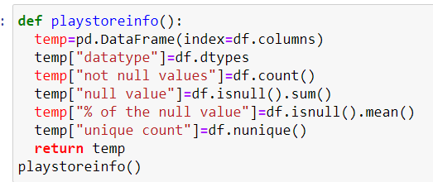

Fig . 1

1. Data Analysis

-The main stem of the project is data analysis. The descriptive study of the various key aspects of the project, on which we had performed various operations of analysis.

-The analysis of the user reviews and ratings for the applications. Which helps us to identify which app is most downloaded and has a more emerging future in future .

1. Visualization

-Creating visualizations by graphs on different analysing aspects. Which tells different trends of the applications of Google Play Store.

-We have used python library “mathplotlib.pyplot” , which is used to represents graph on the basis of data we put.

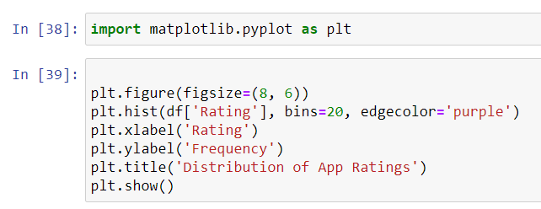

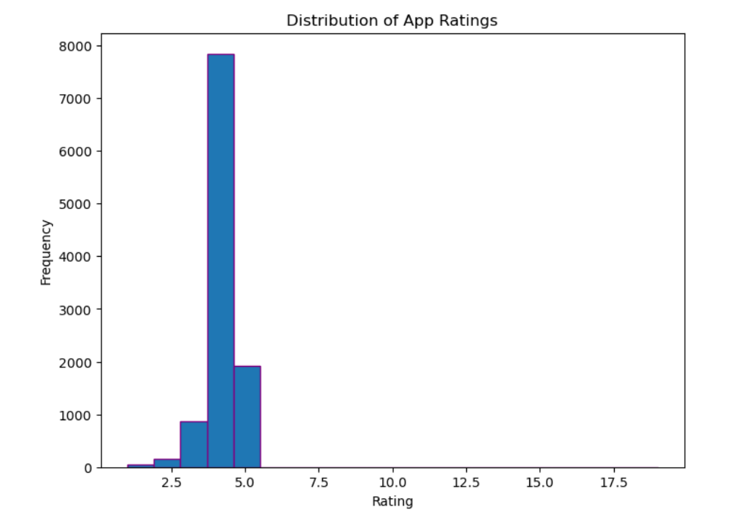

This above is one of the graph in the project which tells the trend of the application rating and frequency of the number of people who have rated .

# Conclusion

In conclusion, this analysis project aimed to unravel the intricate landscape of Google Play Store applications, shedding light on trends, patterns, and insights that hold significance for people who want to download application on the present trends. Through a comprehensive exploration of app categories, user ratings, download counts, categories, several key findings have emerged.

The Google Play Store analysis project serves as a valuable resource for users in the mobile app ecosystem. By combining quantitative data with meaningful analysis, it bridges the gap between raw information and actionable strategies, paving the way for continued innovation and success in the dynamic world of mobile applications.

# References

1. Dataset from Kaggle.com C:\Users\CHAIT\dw&m lab\google play strore app analysis.csv